Team Id= LTVIP2025TMID47570
- INTRODUCTION
  - Project Overview
  - Purpose
- IDEATION PHASE
  - Problem Statement
  - Empathy Map Canvas
  - Brainstorming
- REQUIREMENT ANALYSIS
  - Customer Journey map
  - Solution Requirement
  - Data Flow Diagram
  - Technology Stack
- PROJECT DESIGN
  - Problem Solution Fit
  - Proposed Solution
  - Solution Architecture
- PROJECT PLANNING & SCHEDULING
  - Project Planning
- FUNCTIONAL AND PERFORMANCE TESTING
  - Performance Testing
- RESULTS
  - Output Screenshots
- ADVANTAGES & DISADVANTAGES
- CONCLUSION
- FUTURE SCOPE
- APPENDIX: Source Code (if any), Dataset Link, GitHub & Project Demo Link

INTRODUCTION

Project Overview
ToyCraft is a creative and user-centric platform designed to revolutionize the way toys are discovered, designed, and experienced. In today's fast-paced digital world, choosing the right toy for a child often becomes overwhelming due to the vast number of options and lack of personalization. This project
aims to address that gap by offering an intelligent and interactive environment where users—primarily parents, children, and educators—can explore a
curated selection of toys based on age, learning outcomes, interests, and developmental benefits.
The platform not only recommends toys based on user needs but also introduces an element of creativity by allowing users to virtually design or customize their own toys. It combines educational and recreational values, ensuring that the toys chosen or created serve both fun and developmental
purposes. The system uses data-driven insights, empathy mapping, and design thinking to guide the user through a structured yet playful journey.

Purpose
The main purpose of the ToyCraft project is to simplify and enhance the toy
selection process while promoting creativity and education. It aims to address common challenges such as decision fatigue, lack of personalization, and poor understanding of a toy's learning impact. By applying user research and
empathy-based design, the project ensures that the end users' needs, motivations, and frustrations are well understood and reflected in the final solution.
Additionally, the platform serves as a medium to foster bonding between children and adults through collaborative toy crafting and selection. It
encourages imaginative thinking and skill-building by integrating DIY elements or providing guidance for physical creation. From a broader perspective,
ToyCraft envisions supporting sustainable toy consumption by helping users make conscious and informed choices rather than purchasing impulsively or based on trends alone.

IDEATION PHASE

Customer Problem Statement:
Create a problem statement to understand your customer's point of view. The Customer Problem Statement template helps you focus on what matters to
create experiences people will love.
A well-articulated customer problem statement allows you and your team to find the ideal solution for the challenges your customers face. Throughout the process, you’ll also be able to empathize with your customers, which helps you better understand how they perceive your product or service.
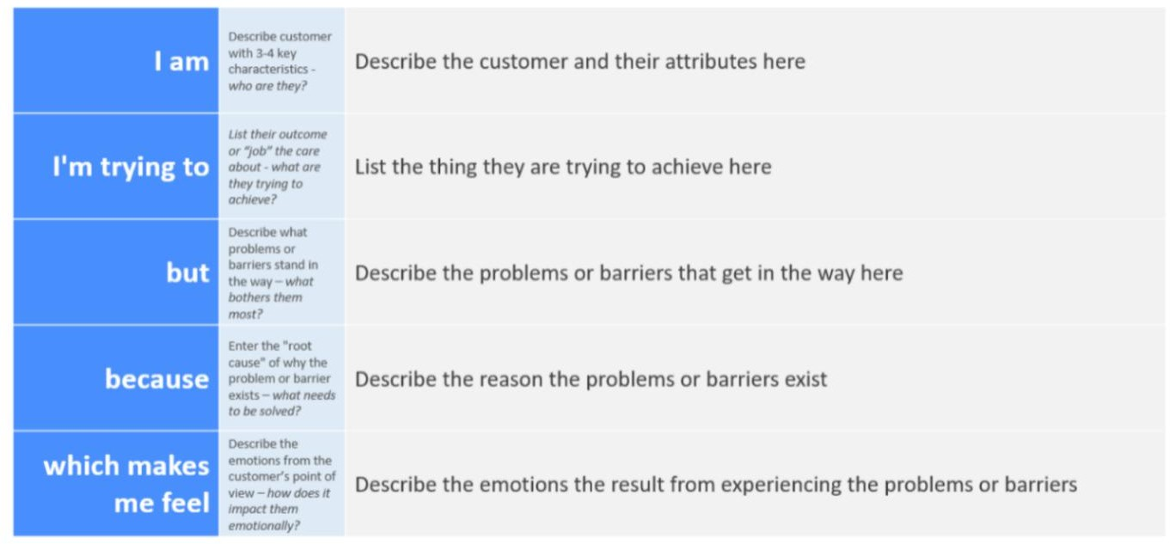

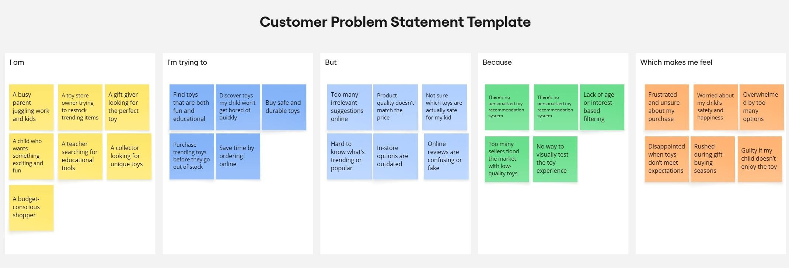

Problem Statement (PS) | I am  (Customer) | I’m trying to | But | Because | Which makes me feel
PS-1 | A busy parent juggling work and kids | Find toys that  are both fun and educational | Too many irrelevant  suggestions online | Platforms focus on sales, not child  engagement | Worried about my child’s safety and happiness
PS-2 | A toy store owner trying to restock  trending items | Purchase  trending toys before they go out of stock | In-store options are outdated | Too many  sellers flood the market with low- quality toy | Disappointed when toys don’t meet expectations

Empathy Map Canvas:
An empathy map is a simple, easy-to-digest visual that captures knowledge about a user’s behaviours and attitudes.
It is a useful tool to helps teams better understand their users. Creating an effective solution requires understanding the true problem and the person who is experiencing it. The exercise of creating the map helps participants consider things from the user’s perspective along with his or her goals and challenges.
To build a solution that genuinely addresses the needs and experiences of the users, we developed an Empathy Map Canvas focusing on our primary user: parents and guardians looking to choose or craft toys for their children. The Empathy Map is a collaborative visualization tool used to articulate what we know about the user. It helps us synthesize observations and draw out insights about user behavior and mindset.
The canvas is divided into six key quadrants—Says, Thinks, Does, Feels, Pains, and Gains—to explore the user’s perspective in depth:

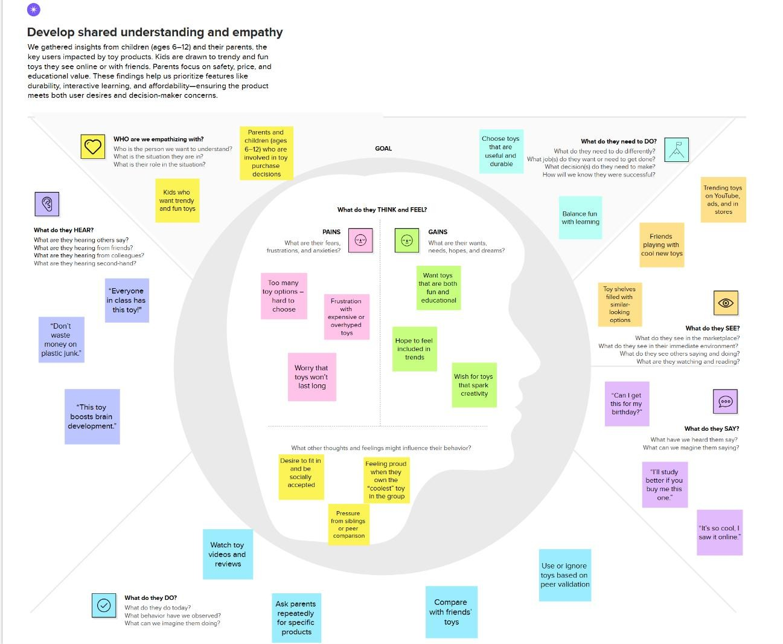

Brainstorming:
Brainstorming provides a free and open environment that encourages everyone within a team to participate in the creative thinking process that
leads to problem solving. Prioritizing volume over value, out-of-the-box ideas
are welcome and built upon, and all participants are encouraged to collaborate, helping each other develop a rich amount of creative solutions. Use this
template in your own brainstorming sessions so your team can unleash their imagination and start shaping concepts even if you're not sitting in the same room.

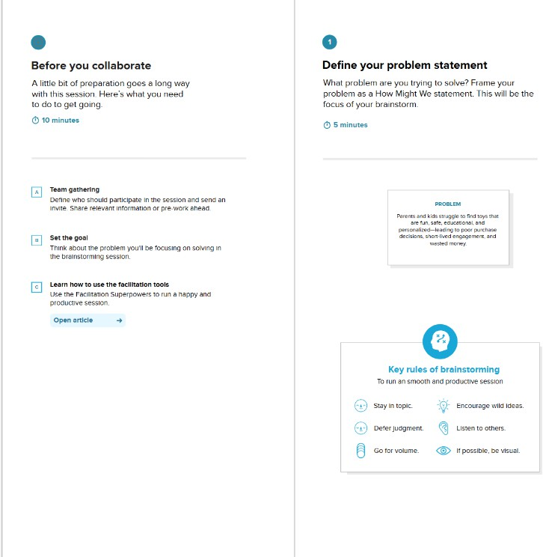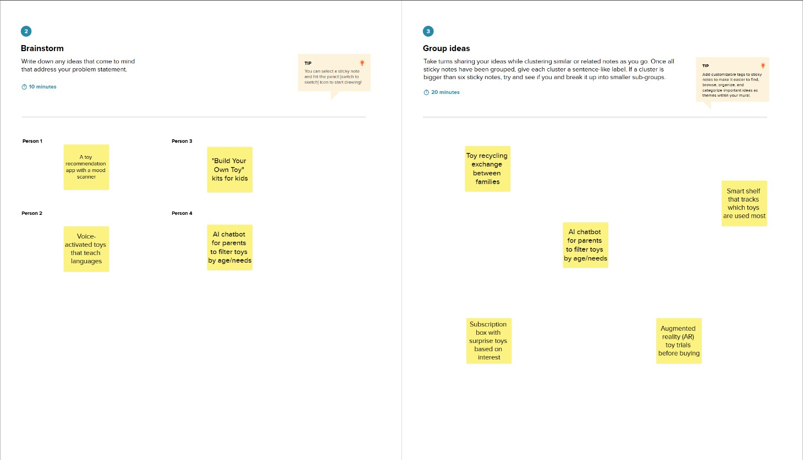

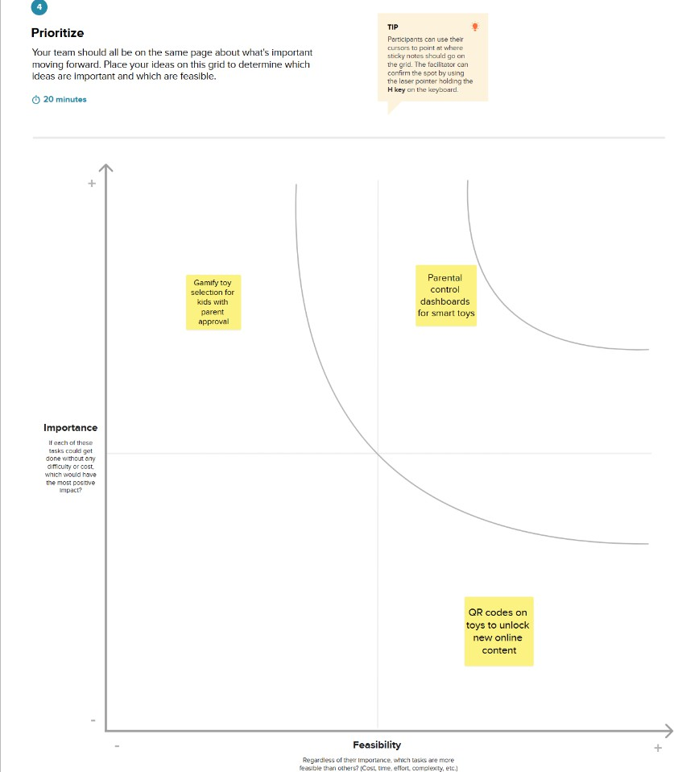

REQUIREMENT ANALYSIS

Customer Journey map:
The Customer Journey Map was created to visualize the experience of a parent or guardian as they interact with the ToyCraft platform. This journey highlights key touchpoints, emotions, and decision-making stages, enabling us to identify friction areas and opportunities for improvement.

Stages:
        - Awareness: The user becomes aware of the platform through social media, word-of-mouth, or a recommendation from an educator.
        - Exploration: They visit the platform and browse available toys, craft ideas, or the customization section.
        - Evaluation: The user filters toys by age, skill focus (e.g., creativity, logic), and preferences. They may use the recommendation assistant or read
reviews.
        - Decision: After shortlisting, they select a toy or generate a custom toy design with the help of the system.
        - Action: They proceed to purchase, download a DIY guide, or initiate a custom craft order.
        - Post-Experience: They receive the toy or build it using the provided guide. Feedback and satisfaction are shared on the platform.
This map helped us identify moments of confusion and delight and align the platform features with user needs at each step.

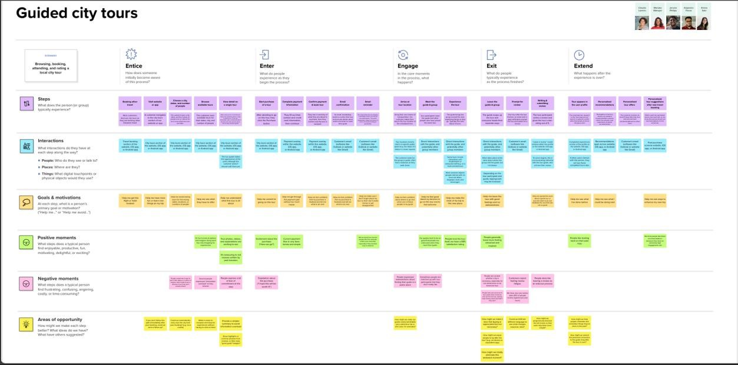

Solution Requirement:
Based on the insights gained from brainstorming and the empathy map, the following functional and non-functional requirements were identified:
Functional Requirements:
- User registration and login
- Toy search with filters (age, category, learning goal, etc.)
- Toy recommendation engine based on user input
- Custom toy crafting interface
- Downloadable DIY craft guides
- Ratings and review section
- Admin dashboard to manage inventory and user feedback

Non-Functional Requirements:
- Intuitive and child-friendly UI/UX
- Mobile and desktop responsiveness
- Fast load time and search performance
- Secure user data storage and safe payment processing
- Scalable architecture for increasing user base
- Integration with third-party APIs (e.g., payment gateway, image generation tools)

Data Flow Diagram:

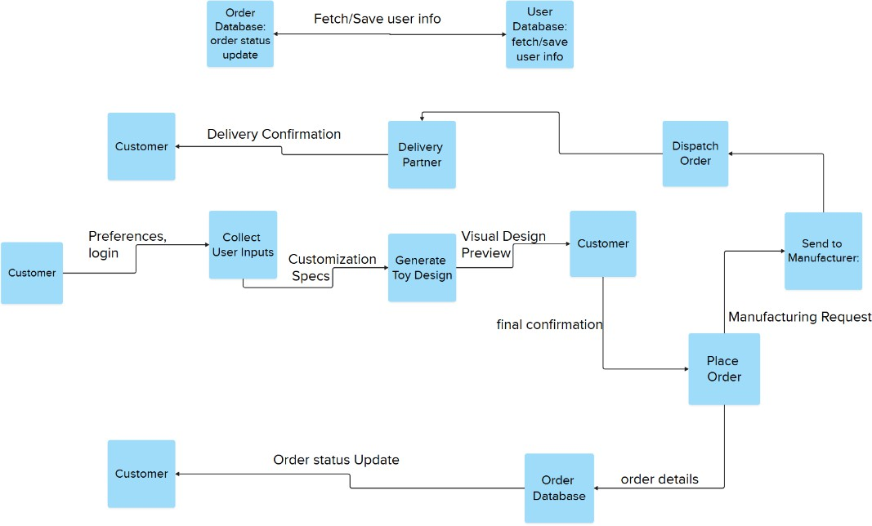

A Level 1 Data Flow Diagram (DFD) was created to represent the flow of data between different modules of the system. The core components include:
- User: Initiates interactions by registering, searching, and crafting.
- Toy Database: Stores all toy information including descriptions, categories, and user reviews.
- Recommendation Engine: Uses user input to suggest suitable toys.
- Customization Module: Allows users to build their own toy from templates or scratch.
- Admin Panel: Handles data management, analytics, and inventory.
The diagram ensures a clear understanding of how data moves within the system, aiding in both design and implementation planning.

      - Technology Stack:

S.No | Component | Description | Technology / Tool
1 | User Interface | Interface to view dashboard and interact with visuals | Tableau Public / Tableau Desktop
2 | Application Logic-1 | Data preprocessing and transformation | Python (Pandas), Tableau prep tools
3 | Application Logic-2 | Creating calculated fields and data filters | Tableau Calculated Fields
4 | Application Logic-3 | Visualization logic and chart rendering | Tableau Visualization Engine
5 | Database | Local storage of CSV dataset | Flat File (.CSV)
6 | Cloud Database | (Optional) Hosting dataset on cloud for Tableau Cloud  usage | Google Sheets / Tableau Cloud
7 | File Storage | Where source dataset is stored before uploading to  Tableau | Local Filesystem / Google Drive
8 | External API-1 | Not used (N/A for this dashboard) | N/A
9 | External API-2 | Not used | N/A
10 | Machine Learning Model | Not used in current scope | N/A
11 | Infrastructure | System used for dashboard design and publishing | Local (Windows/MacOS) / Tableau Public

PROJECT DESIGN

Problem Solution Fit:
The Problem-Solution Fit simply means that you have found a problem with your customer and that the solution you have realized for it actually solves the customer’s problem. It helps entrepreneurs, marketers and corporate
innovators identify behavioral patterns and recognize what would work and why.

Purpose:
- Solve complex problems in a way that fits the state of your customers.
- Succeed faster and increase your solution adoption by tapping into existing mediums and channels of behavior.
- Sharpen your communication and marketing strategy with the right triggers and messaging.
- Increase touch-points with your company by finding the right problem- behavior fit and building trust by solving frequent annoyances, or urgent or costly problems.
- Understand the existing situation in order to improve it for your target group.

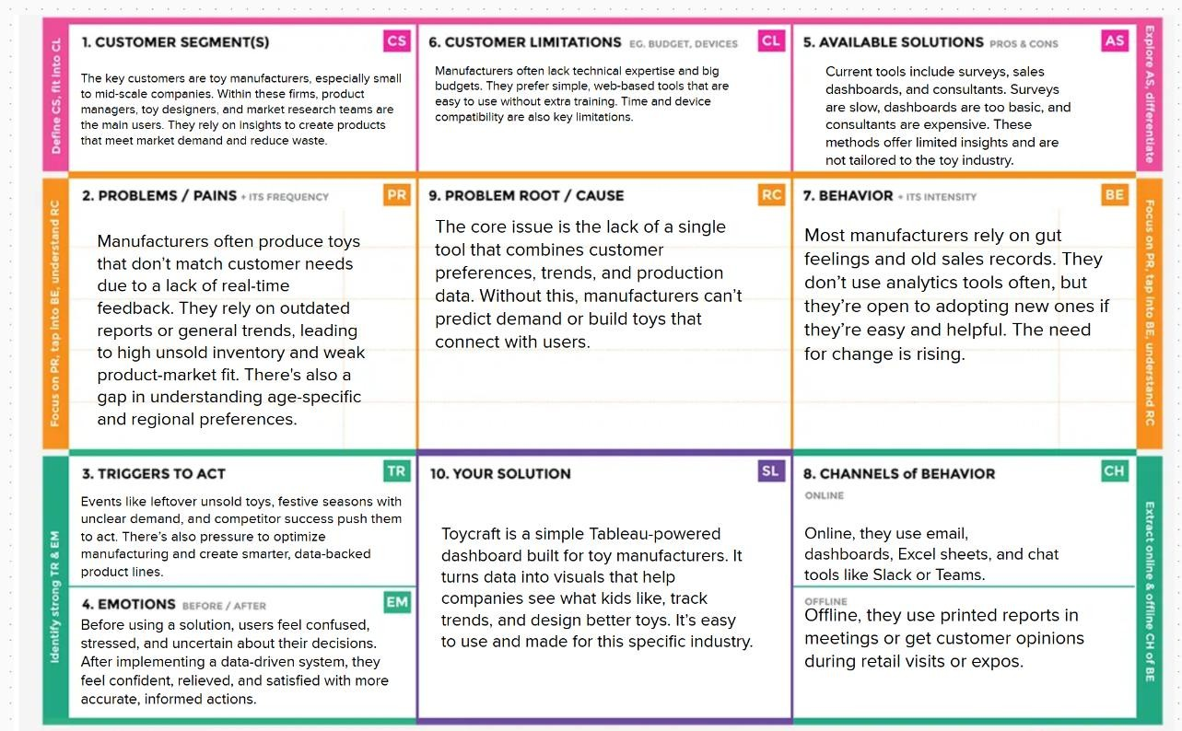

Proposed Solution:

S.No. | Parameter | Description
1. | Problem Statement (Problem to be solved) | Toy manufacturers often lack detailed insights into customer  preferences and evolving toy trends. This leads to overproduction, underperformance, or irrelevant  designs.
2. | Idea / Solution description | Toycraft is a data-driven solution using Tableau dashboards to visualize customer insights, production patterns, and trend analytics. It helps manufacturers understand what toys are in demand, which designs are

 |  | underperforming, and how to optimize their inventory and customization options based on real-time market and user data.
3. | Novelty / Uniqueness | Combines interactive Tableau dashboards with toy customization feedback loops. Unlike standard BI tools, it’s tailored specifically for toy manufacturers and integrates with customer reviews, seasonal trends, and regional preferences.
4. | Social Impact / Customer Satisfaction | Enables toy makers to build better, more meaningful toys aligned with developmental goals. Children get toys they love; parents feel confident in purchases;  manufacturers reduce waste and boost satisfaction.
5. | Business Model (Revenue Model) | SaaS-based licensing model for toy manufacturers to access the dashboard. Additional revenue via premium analytics modules,  consultancy, and toy trend forecasting reports.
6. | Scalability of the Solution | Easily extendable to various geographies, toy categories, or even different industries. Modular dashboard components allow addition of more data sources and deeper AI-driven insights over time.

      - Solution Architecture:
Solution architecture is a complex process – with many sub-processes – that
bridges the gap between business problems and technology solutions. Its goals are to:
- Find the best tech solution to solve existing business problems.
- Describe the structure, characteristics, behavior, and other aspects of the software to project stakeholders.
- Define features, development phases, and solution requirements.
- Provide specifications according to which the solution is defined, managed, and delivered.

Goals of the Architecture
- Find the best tech solution to visualize how product position, price, promotions, and
customer demographics affect sales volume.
- Define the system's structure and behavior using Tableau Public for dashboards and
Python/Tableau for preprocessing.
- Outline features, components, and development phases clearly for visualization and
interaction.
- Provide technical specifications for implementation and scaling.

Architecture Components
Layer Component Description
Data Layer Source: Product Positioning.csv file with fields like Sales Volume, Foot Traffic,Demographics, Promotion, etc.

Processing Layer Data cleaning, formatting, and calculated fields in Tableau or via Python (optional).
Application Layer Tableau logic engine for filters, calculations, and chart rendering.

Presentation Layer Final dashboard built in Tableau with interactive visuals: bar, funnel, donut,waterfall, etc.

Users Retail managers, marketing executives, analysts – accessing via Tableau Public or PDF reports.

Solution Architecture Diagram:
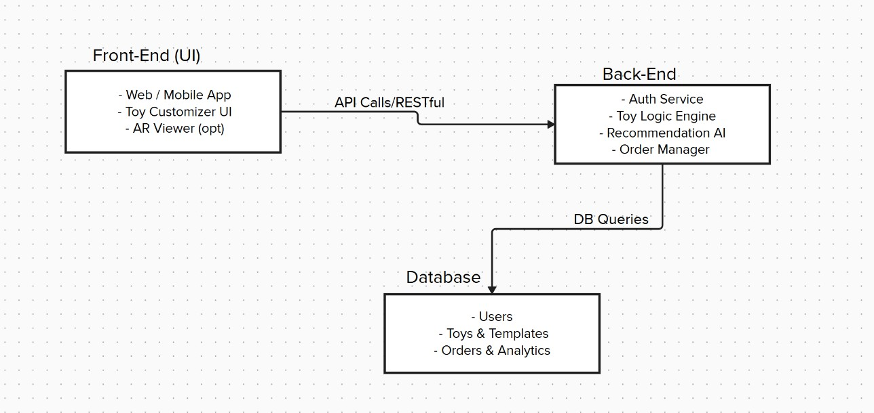

PROJECT PLANNING & SCHEDULING

Project Planning:
Use the below template to create product backlog and sprint schedule

Sprint | Functional Requirement (Epic) | User Story  Numbe r | User Story / Task | Story Point s | Priority | Team Member s
Sprint  -1 | Data  Preparation | USN-1 | As an analyst, I want to clean and  inspect the dataset for nulls or anomalies. | 2 | High | A1
Sprint  -1 | Data  Preparation | USN-2 | As an analyst,  I want to rename  columns for easy access and remove index column. | 1 | Mediu m | A2
Sprint  -2 | Trend Analysis | USN-3 | As a user, I want to see a line chart showing  yearly changes in total  manufacturer s. | 3 | High | A1

Sprint | Functional Requirement (Epic) | User Story  Numbe r | User Story / Task | Story Point s | Priority | Team Member s
Sprint  -2 | State-Level Comparison | USN-4 | As a user, I want a bar chart showing top 10 states by average manufacturer s. | 3 | High | A2
Sprint  -3 | Interactive Dashboard | USN-5 | As a user, I want to filter manufacturer data by year and state interactively. | 4 | High | A3
Sprint  -3 | Visual Summary | USN-6 | As a user, I want to view a heatmap showing  state-wise performance over years. | 3 | Mediu m | A1
Sprint  -4 | Insights and Story | USN-7 | As a  presenter, I want a slide- based story showing key findings and conclusions. | 4 | High | A2

Sprint | Functional Requirement (Epic) | User Story  Numbe r | User Story / Task | Story Point s | Priority | Team Member s
Sprint  -4 | Project Delivery & Documentatio n | USN-8 | As a team, we want to  prepare a final report with visualizations and insights. | 4 | High | A3

Project Tracker, Velocity & Burndown Chart: (4 Marks)

Sprint | Total Story Points | Duration | Start Date | End Date | Points Completed | Release Date
Sprint- 1 | 3 | 6 Days | 10 Jul  2025 | 15 Jul  2025 | 3 | 15 Jul  2025
Sprint- 2 | 6 | 6 Days | 16 Jul  2025 | 21 Jul  2025 | 6 | 21 Jul  2025
Sprint- 3 | 7 | 6 Days | 22 Jul  2025 | 27 Jul  2025 | 7 | 27 Jul  2025
Sprint- 4 | 8 | 6 Days | 28 Jul  2025 | 2 Aug  2025 | 8 | 2 Aug  2025

Velocity:
Imagine we have a 10-day sprint duration, and the velocity of the team is 20 (points per sprint). Let’s calculate the team’s average velocity (AV) per iteration unit (story points per day)

Velocity = Total Story Points Completed / Number of Sprints
= (3 + 6 + 7 + 8) / 4
= 6.0 story points per sprint

FUNCTIONAL AND PERFORMANCE TESTING

Model Performance Testing:
Project team shall fill the following information in model performance testing template.

S.  No  . | Paramete r | Screenshot / Values
1 | Data Rendered | 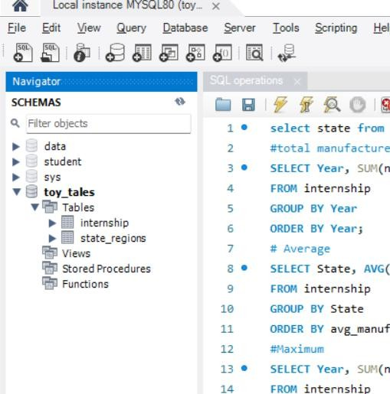
2. | Data  Preproces sing | 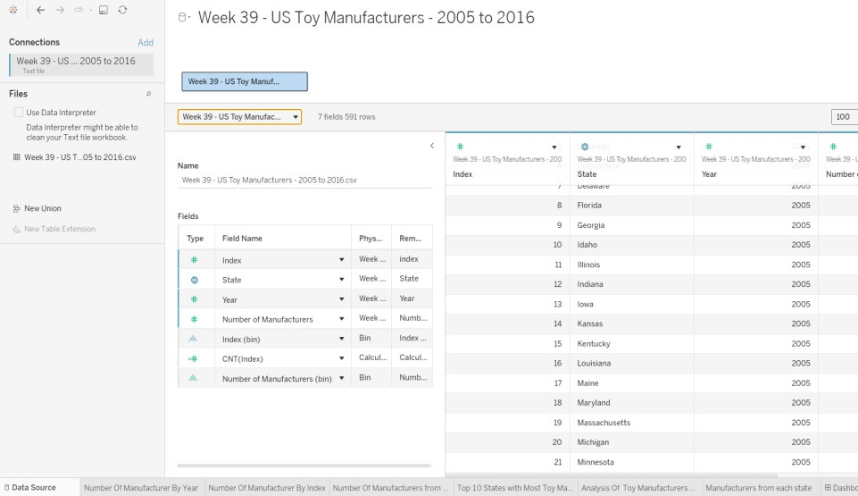

3. | Utilization of Filters | The fields Year and State are majorly used as Filters.
4. | Calculatio n fields Used | Index(BIN), CNT(Index) are the calculation fields used for analysis.
5. | Dashboar d design | No of Visualizations / Graphs – 6  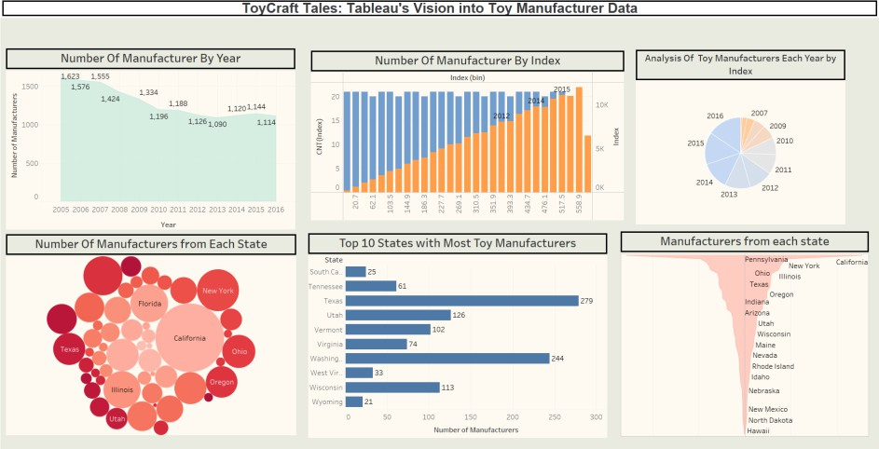
6 | Story Design | No of Visualizations / Graphs –5  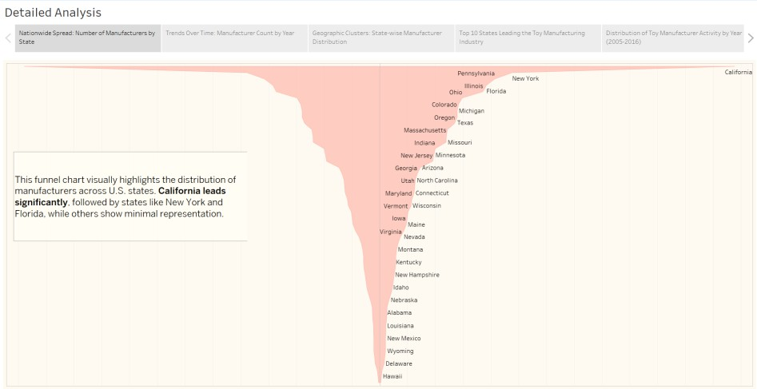

RESULTS
      - OUTPUT SCREENSHOTS:
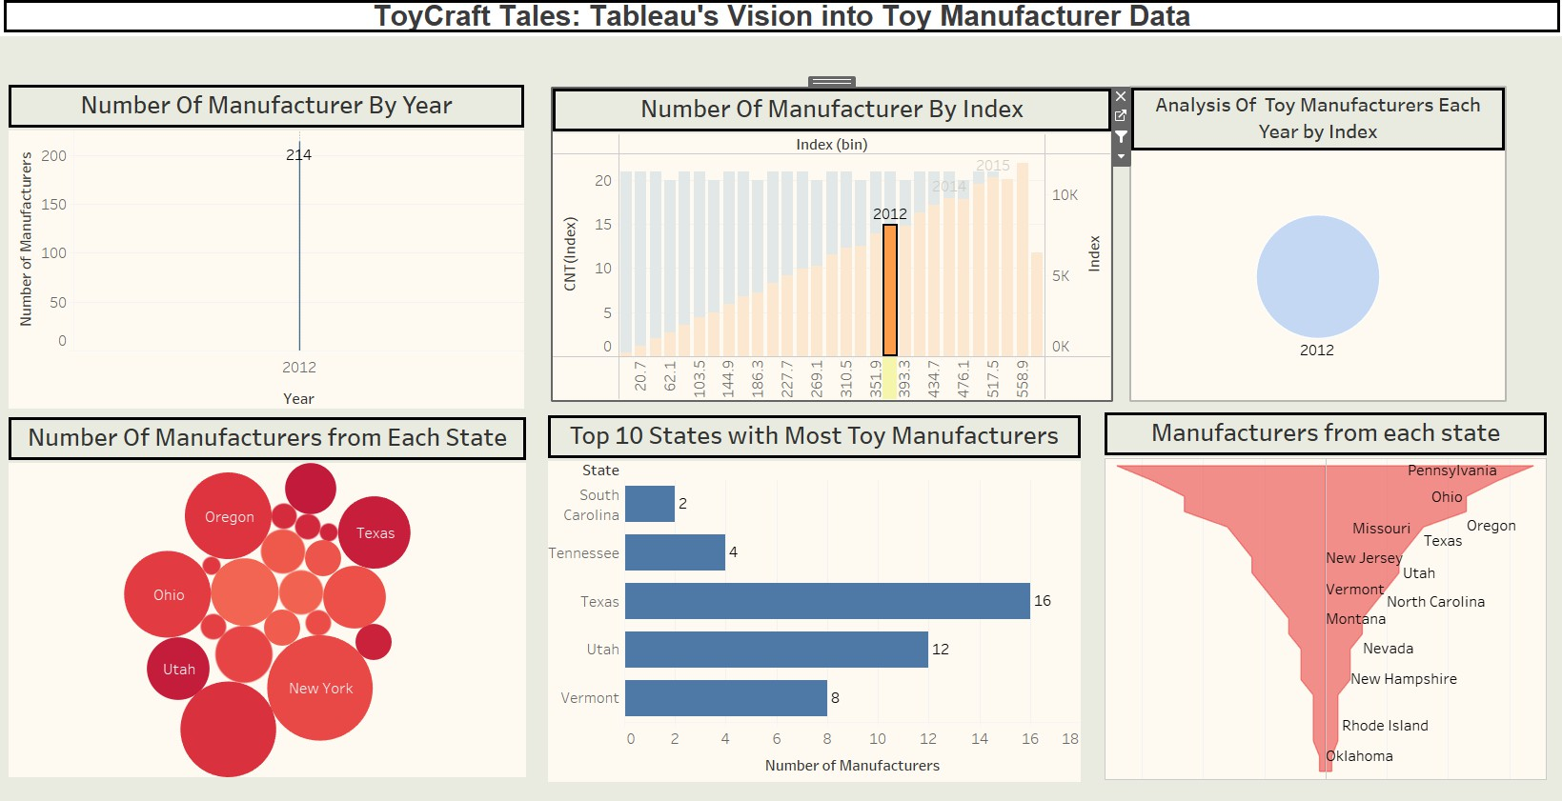

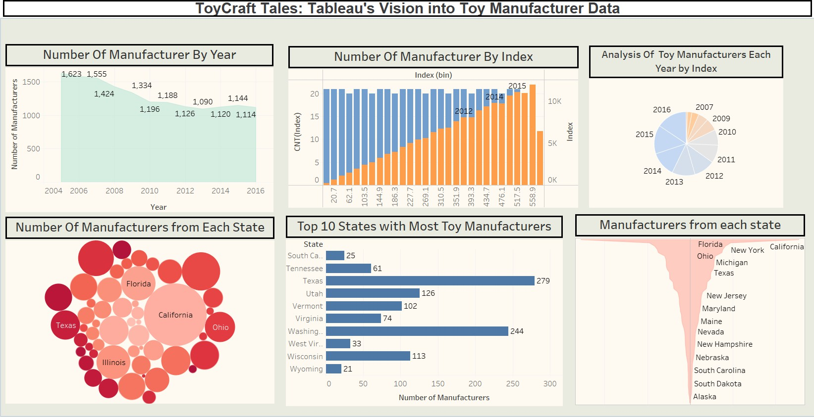

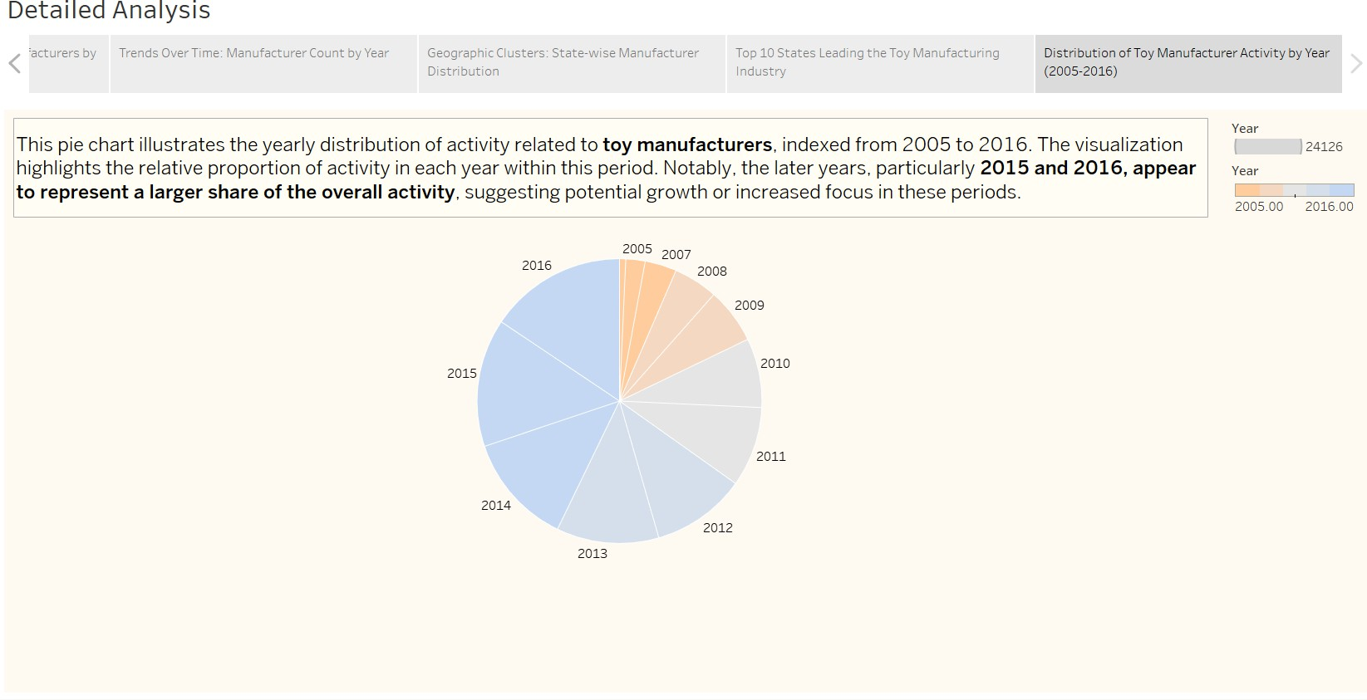

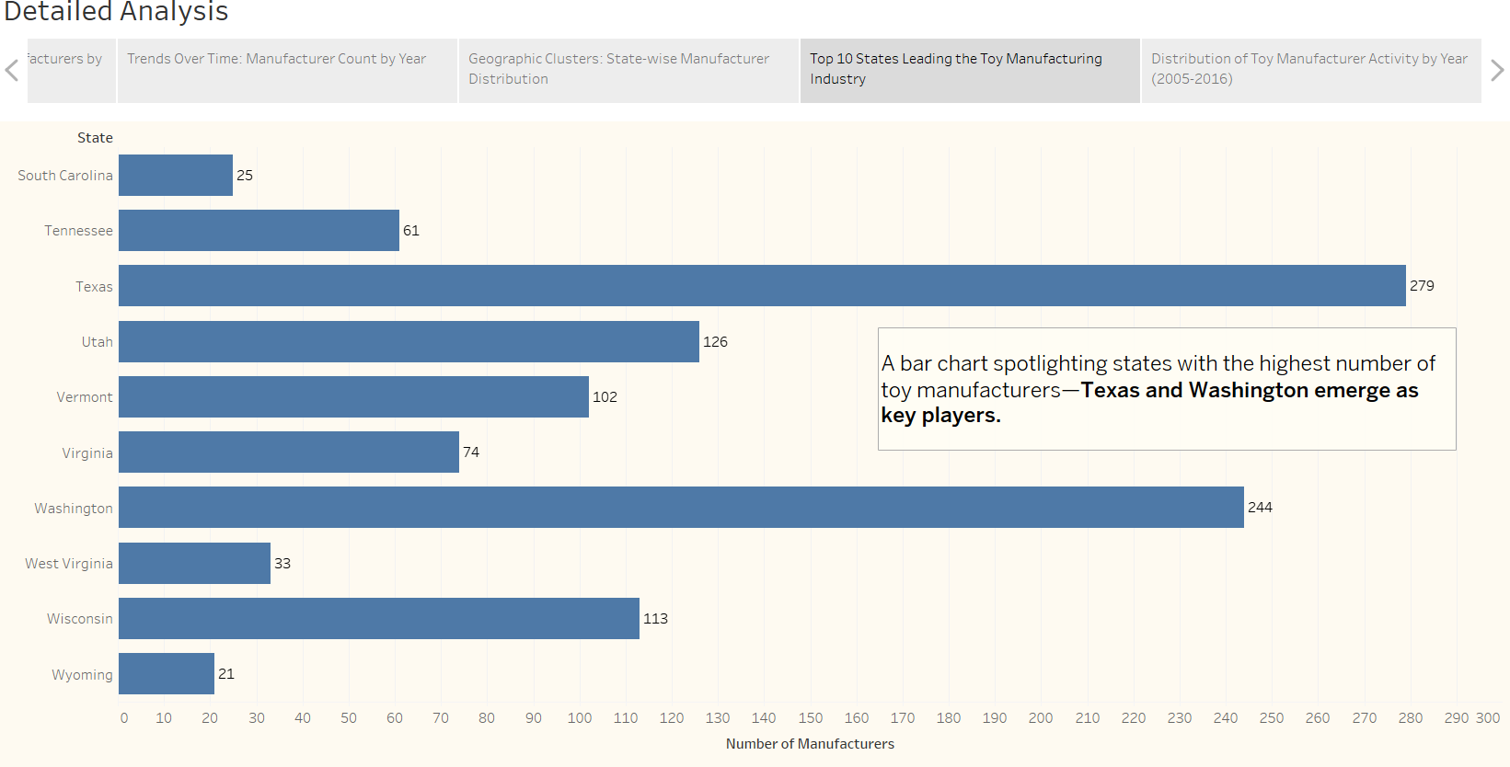

ADVANTAGES & DISADVANTAGES

Advantages
- User-Centered Design: The entire platform is built around real user needs identified through empathy mapping and journey mapping, ensuring high relevance and usability.
- Personalization: ToyCraft offers personalized toy recommendations
based on age, interest, and developmental goals, making the selection process more meaningful.
- Creative Engagement: The customization and DIY features encourage creativity, allowing users to craft unique toys and engage in hands-on learning.
- Educational Value: By focusing on skill-based toy categorization (STEM, logic, art, etc.), ToyCraft ensures that playtime also supports cognitive development.
- Scalability: The architecture is designed to support feature expansion, third-party integration, and a growing user base without major changes.
- Time-Saving: Smart filtering and recommendations help users quickly find toys that suit their needs, reducing decision fatigue.

Disadvantages
- No Advanced AI Yet: The current recommendation system is basic and does not include AI or machine learning for adaptive personalization.
- Web-Only Platform: As of now, ToyCraft is only available on web browsers. Users looking for mobile accessibility may find this limiting.
- DIY Accessibility: Some DIY toy guides may require materials or tools that are not easily available to all users, especially in rural areas.
- Limited Real-Time Interaction: There is no collaborative feature for multiple users (like a parent and child) to customize toys together in real time.

- Initial Inventory Management: Curating and maintaining a diverse, high- quality toy database (especially for user-generated designs) can be
resource-intensive during early phases.

CONCLUSION
ToyCraft is a user-centered solution built on empathy, creativity, and innovation. By addressing key challenges faced by parents and children in the toy selection process, the platform introduces a seamless and interactive way to discover, personalize, and craft toys that matter.

From brainstorming and empathy mapping to designing the architecture and defining features, every step of the project has been aligned with real user needs. While there are limitations in its current form, the foundation laid by this project opens doors for future improvements and real-world applications.

In conclusion, ToyCraft aims to redefine how toys are experienced — not just as products, but as tools of connection, learning, and imagination.

FUTURE SCOPE
The future of ToyCraft holds significant potential for technological enhancement, user engagement, and market expansion. Below are some possible areas of growth:
- AI-Powered Recommendations: Implementing advanced AI and behavioral analytics to understand user preferences and improve toy suggestions over time.
- Mobile App Development: Launching a fully optimized mobile app for Android and iOS to make the platform accessible on-the-go.

- 3D Toy Visualization: Allowing users to see 3D previews of custom-
designed toys for better visualization before downloading or purchasing.
- Real-Time Collaboration Features: Introducing live co-creation sessions where parents and children can customize toys together remotely.
- Gamification: Adding achievement systems, badges, and creative challenges to encourage regular use and creativity.
- Marketplace Integration: Partnering with toy makers or allowing small- scale creators to sell their custom-designed toys through the platform.
These enhancements will make ToyCraft not just a toy discovery tool, but a
complete ecosystem for creative, educational, and engaging toy interactions.

APPENDIX

Dataset Link: https://docs.google.com/spreadsheets/d/1UjCzqXYFdENnL- NDPYPgfH6E0Hap1VeMwPdDB5e79A8/edit?usp=sharing

GitHub Link: https://github.com/Ash-rith/ToyCraft-Tales

Project Demo Link:
https://drive.google.com/file/d/1pqyPkiI9JrvJ9at6V_EPH4ozz1fpRBOX/view?us p=sharing

